Vehicle Service & Repair Request Management

Section A — Owner Details
- Owner Name (First Name, Last Name)
- Vehicle Registration Number (Single Line)
- Vehicle Type (Drop Down)
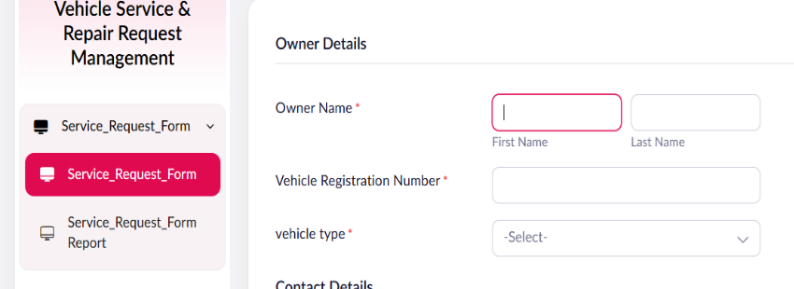

Section B — Contact Details
- Email Address (Email field)
- Contact Number (Phone field)
- Pickup Address (Address field)
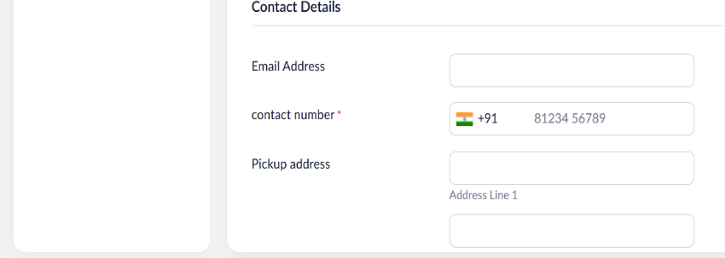
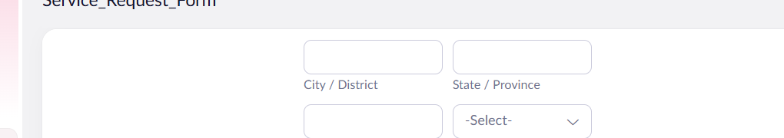

Section C — Vehicle & Issue Details
- Odometer Reading (Number field)
- Service Type (Radio: Routine Service / Breakdown Repair / Accident Repair)
- Additional Services Requested (Multi Select)
- Issue Description (Multi Line)
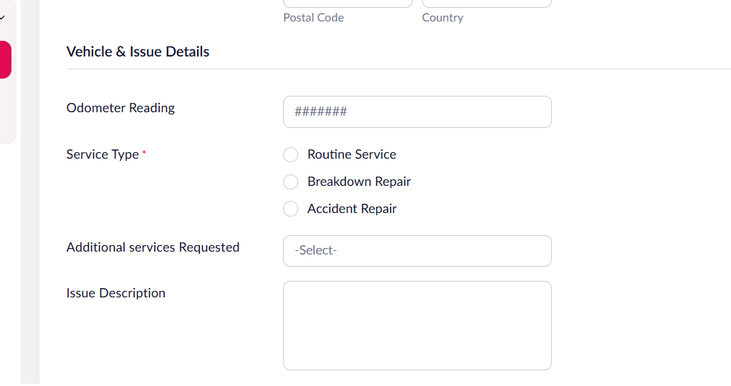

Section D — Scheduling & Authorization
- Preferred Service Date (Date field)
- Preferred Drop-off Time (Time field)
- I authorize the service center to prepare an estimate and proceed (Checkbox)
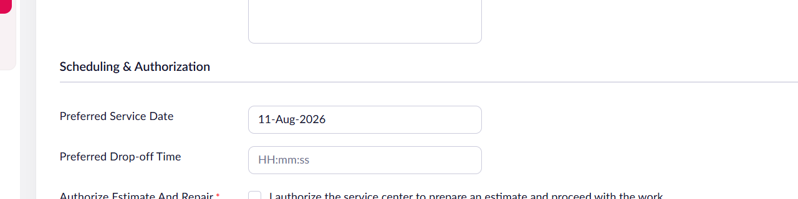

6. Validation Rules to Configure
- Owner Name, Phone, Vehicle Registration Number, Vehicle Type, Service Type, and Authorization Checkbox are mandatory fields.
- Email field: built-in email format validation enabled.
- Phone field: country code format enabled for Indian numbers.
- Number field (Odometer Reading): restrict to a positive value only.
- Date field: restrict Preferred Service Date to disallow past dates.
- Checkbox (Authorization): form cannot be submitted unless checked.

7. Workflow Summary
- Owner opens the public form link shared via the service center's website or SMS.
- Owner fills in personal, vehicle, issue, and scheduling details across the four sections.
- On clicking Submit, Zoho Creator validates all mandatory fields and formats.
- A new record is created in the Service_Request_Report.
- An automated acknowledgement email (using the Email field value) is triggered to the owner.
- The service center reviews the report, filters by Service Type and Preferred Service Date, and assigns a technician and service bay ahead of the vehicle's arrival.

Sample Reports
Submitted records view (Service_Request_Form Report):
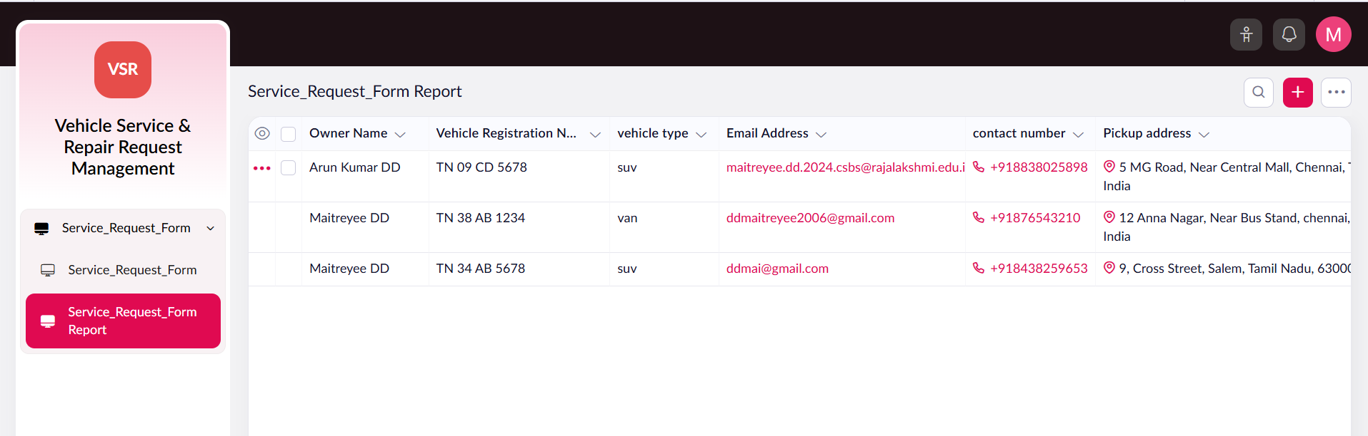

Printed record view:
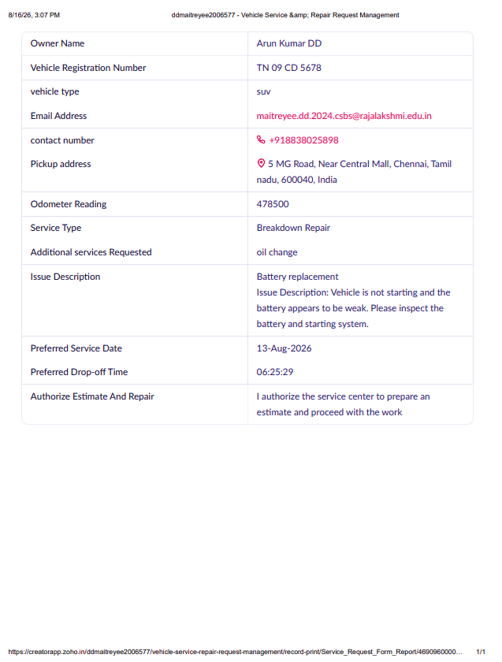

Automated acknowledgement email sent to the owner:
